**OLX Resale**

**Use Case Document**

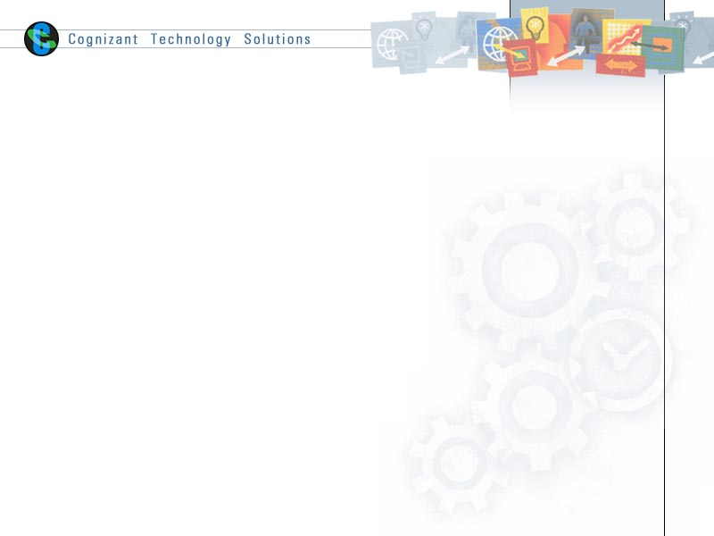

|  |  |  |  |  |  |
| --- | --- | --- | --- | --- | --- |
| **Name** | Abiranjeetha A R | Srinithi I | Suganthi S | Praveen Christhu Raj |  |
| **Role** | Team Member | Team Member | Team Member | Team Member | Scrum Master |
| **Date** | 27/5/2019 | 27/5/2019 | 27/5/2019 | 27/5/2019 |  |

Table of Contents

1.0 Introduction 3

1.1 Purpose & Scope of the document 3

1.2 Intended Audience 3

1.3 Use case ‘User signup’ 3

1.3.1 Use case attributes 3

1.3.2 Use Case Model 4

1.3.3 Business Rules 4

1.3.4 UI Requirements 5

1.3.5 UI Field Validations 6

1.4 Use case ‘User Login’ 6

1.4.1 Use case attributes 6

1.4.2 Use Case Model 7

1.4.3 Business Rules 8

1.4.4 UI Requirement 8

1.5 Use case ‘Sell product’ 10

1.5.1 Use case attributes 10

1.5.2 Use Case Model 11

1.5.3 Business Rules 12

1.5.4 UI Requirement 12

1.6 Use case ‘Product description’ 14

1.6.1 Use case attributes 14

1.6.2 Use Case Model 15

16

1.6.3 Business Rules 16

1.6.4 UI Requirement 16

1.7 Use case ‘User cart’ 17

1.7.1 Use case attributes 17

1.7.2 Use Case Model 18

1.7.3 Business Rules 19

1.7.4 UI Requirement 19

1.8 Use case ‘User ads’ 21

1.8.1 Use case attributes 21

1.8.2 Use Case Model 23

1.8.3 Business Rules 23

1.8.4 UI Requirement 23

2.0 Database Design 25

2.1 Tables Structure 25

List of tables: 25

3.0 Change Log 28

# 1.0 Introduction

## Purpose & Scope of the document

The purpose of this Use case document is to systematically capture requirements for the project and the system to be developed in terms of use cases. Functional use cases are captured in this document. It also serves as the input for the project scoping.

The scope of this document is limited to addressing the use cases from a user, quality, and non-functional perspective.

## Intended Audience

Each member of the project team

## Use case ‘User signup’

### Use case attributes

**Use Case Description:**

This use case deals with the capture of user details. The user who have not registered already here shall be the operator of the system and will be providing the user information into the system.

**Scope:**

* User signup

**Actors:**

* New user

**Trigger:**

Click ‘Sign up’ button in the ‘User Signup’ page

**Pre-Condition:**

The user email-id must not have been already registered. The user must have a valid email-Id.

**Post Condition:**

After successful signup the user can try logging in.

**Flow of Events:**

User at signuppage 🡪 Click ‘Sign up’ button 🡪 User details are submitted and added onto the database.

**Primary Scenario:**

A new user – is able to click ‘Sign up’ button and able to provide his details and get enrolled in the system.

### Use Case Model

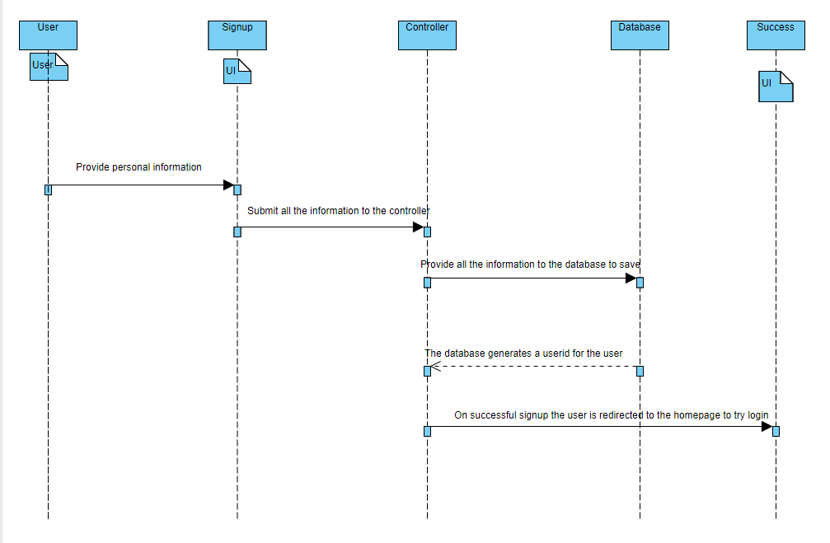

### Business Rules

Business rules should be defined using the following attributes: -

* When the user clicks on the signup button, it should re-direct to signup form.
  + - User needs to fill some of the basic attributes/fields as mentioned below in requirement: First Name, Last Name, Age, Gender, Contact Number, Password, Email-id, Address.
* Clicking ‘Sign up’ should validate the datatype constraints for each field
* Post-successful field level validation, save the information in the database
* Upon saving the information in the database, display the message ‘Signup successful, try using login

page’.

### UI Requirements

Here is a prototype on how the homepage should look like.

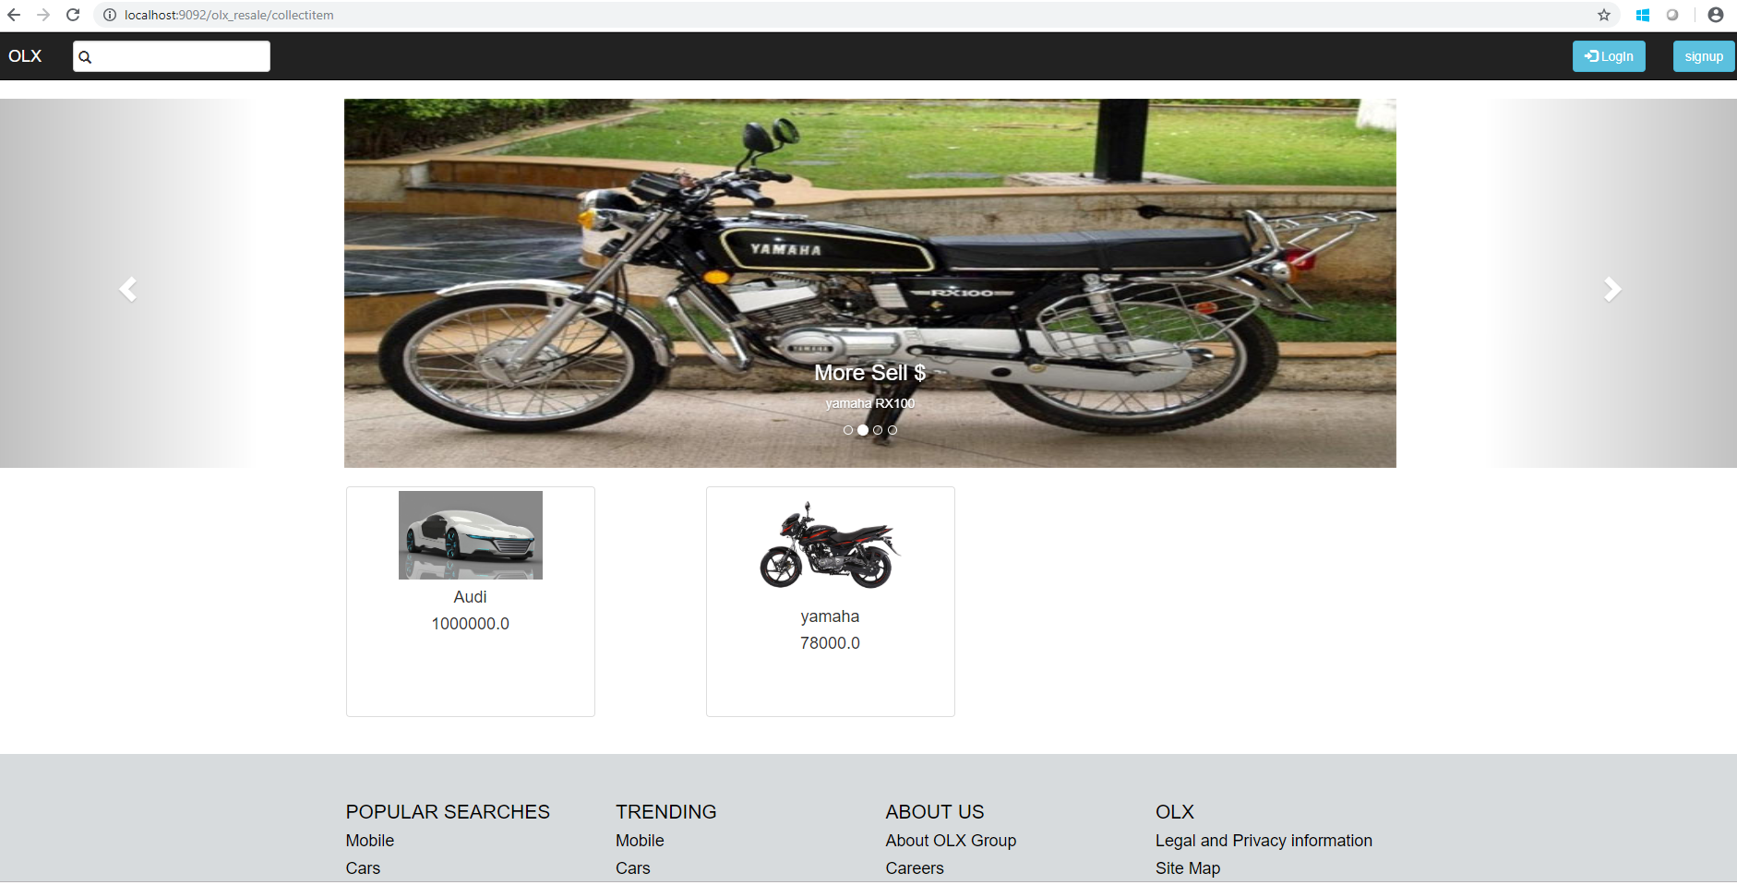

Here is a prototype on how the ‘Registration’ page should look like.

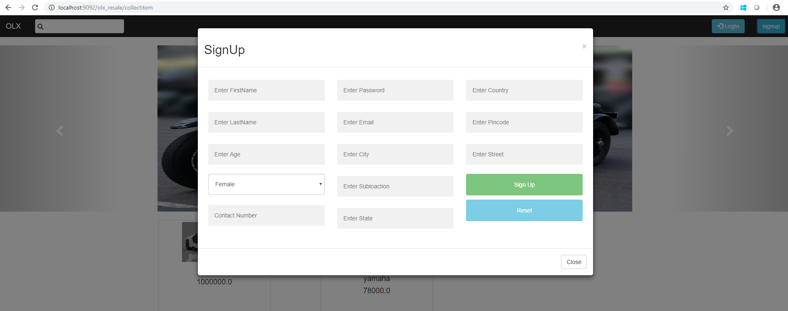

### UI Field Validations

Please refer to the below requirements for field level validations:

* All fields are mandatory.
* The mobile format must be checked. (For ex.9876543210)
* The password must contain minimum of 6 characters.
* The email Id must be in the valid Id format.
* The first name and last name must start with capital letters.

## Use case ‘User Login’

### Use case attributes

**Use Case Description:**

This use case deals with the authentication of the user credentials. The ‘user’ here shall be the operator of the system and will be performing the required tasks

**Scope:**

* User credentials authentication

**Actors:**

User – the operator

**Trigger:**

Click Login button after providing valid email-Id and password.

**Pre-Condition:**

User must have already signed up by providing the user details.

**Post Condition:**

After successful login, the user is allowed to access the list of services provided by the olx resale.

**Flow of Events:**

User at loginpage 🡪 Provide the valid email-Id and password 🡪 Click ‘Login’ button 🡪 User credentials are submitted and verified in the database 🡪 After successful verification 🡪 List of services page.

**Primary Scenario:**

A registered user can provide registered email-Id and password and login to access the list of services provided by the OLX resale.

### Use Case Model

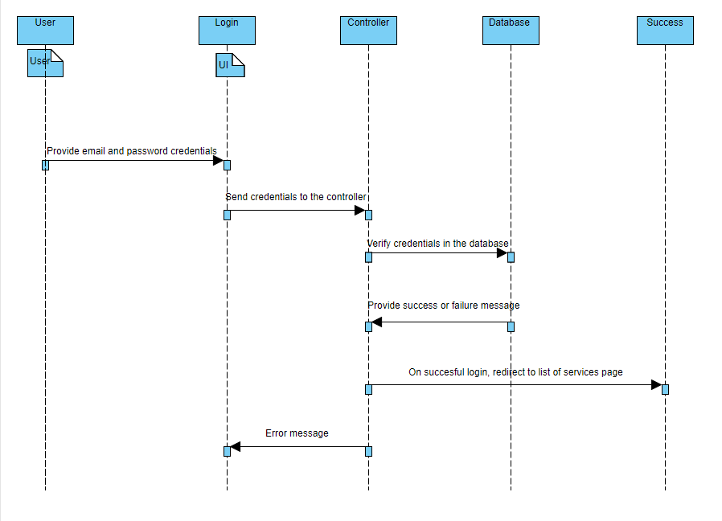

### Business Rules

Business rules should be defined using the following attributes: -

* A registered user is able login, by providing the email and password that he has provided during the signup.

### UI Requirement

Here is a prototype on how the login page should look like.

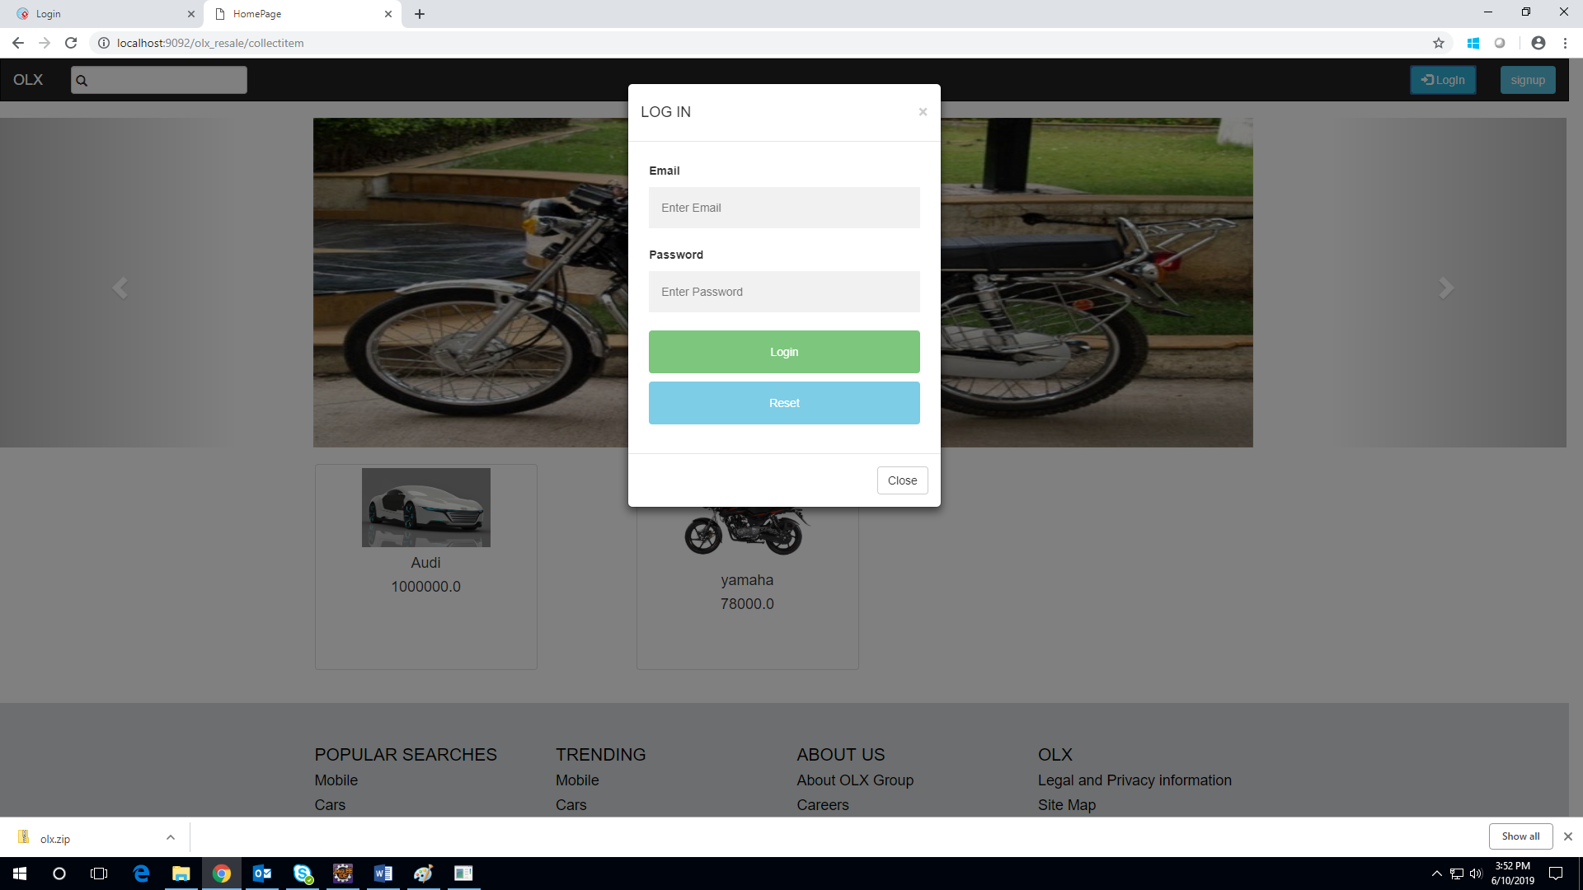

Here is a prototype on how the list of services page should look like.

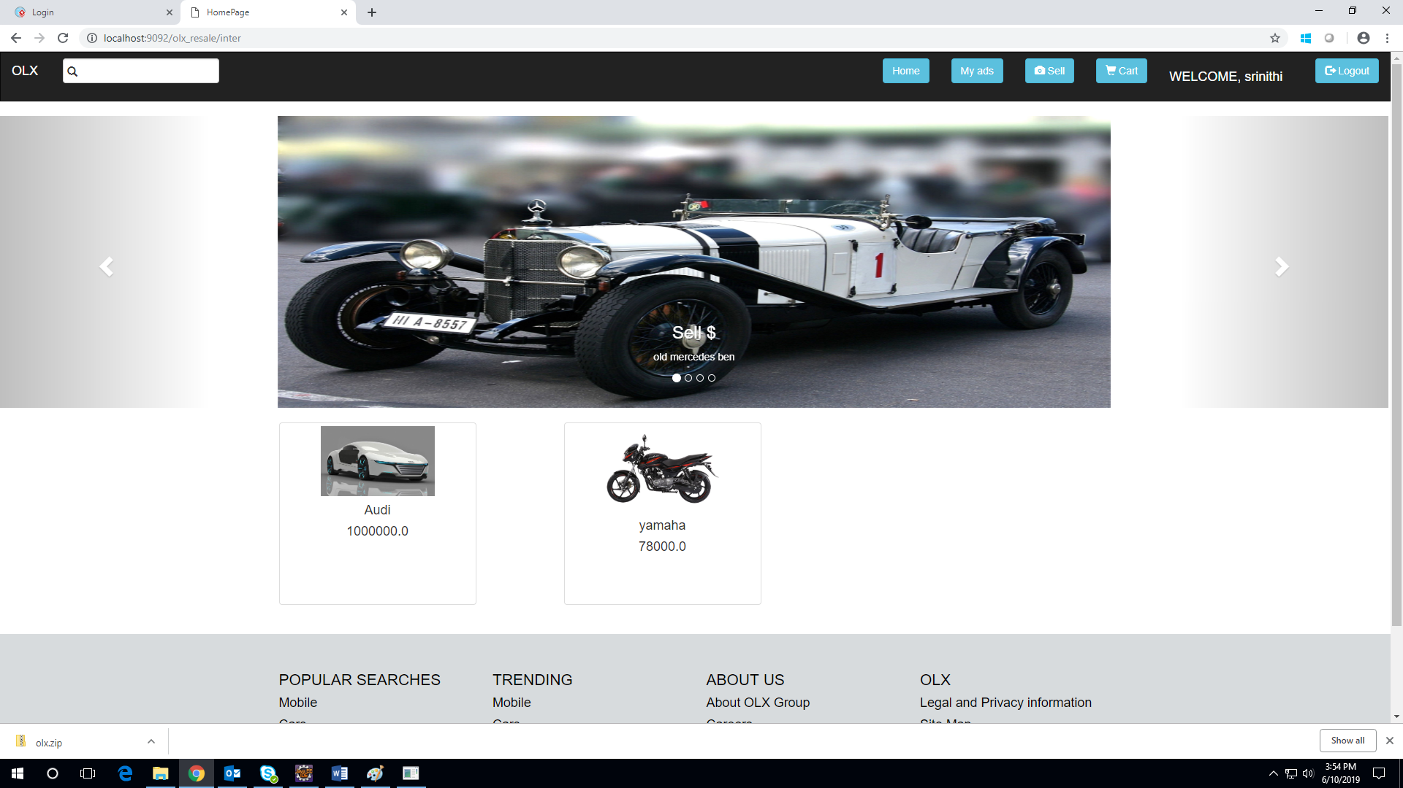

## Use case ‘Sell product’

### Use case attributes

**Use Case Description:**

The user who wants to sell the product can click on the sell button. The ‘user’ is redirected to the sell page which collects information about the product to be sold.

**Scope:**

* The product can be sold.

**Actors:**

The registered user

**Trigger:**

Click ‘Submit’ button to post the ad successfully.

**Pre-Condition:**

The user must have logged in successfully to post the ad.

**Post Condition:**

If the ad is posted successfully, the product is displayed in the homepage.

**Flow of Events:**

Post the ad 🡪 Click the submit button 🡪 The product details are stored in the database 🡪 Product is added to the homepage

**Primary Scenario:**

A registered user is capable of selling the product.

### Use Case Model

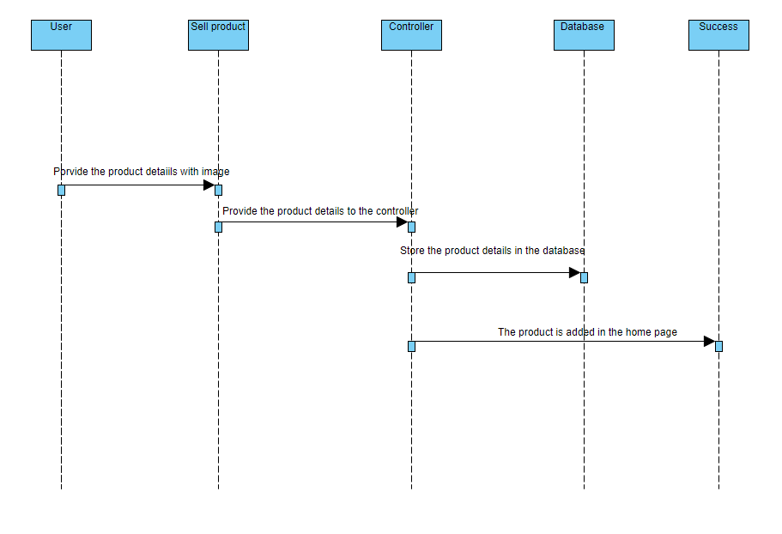

### Business Rules

Business rules should be defined using the following attributes: -

* The product details after being stored in the database must be displayed in the home page.

### UI Requirement

Here is a prototype on how the sell page should look like

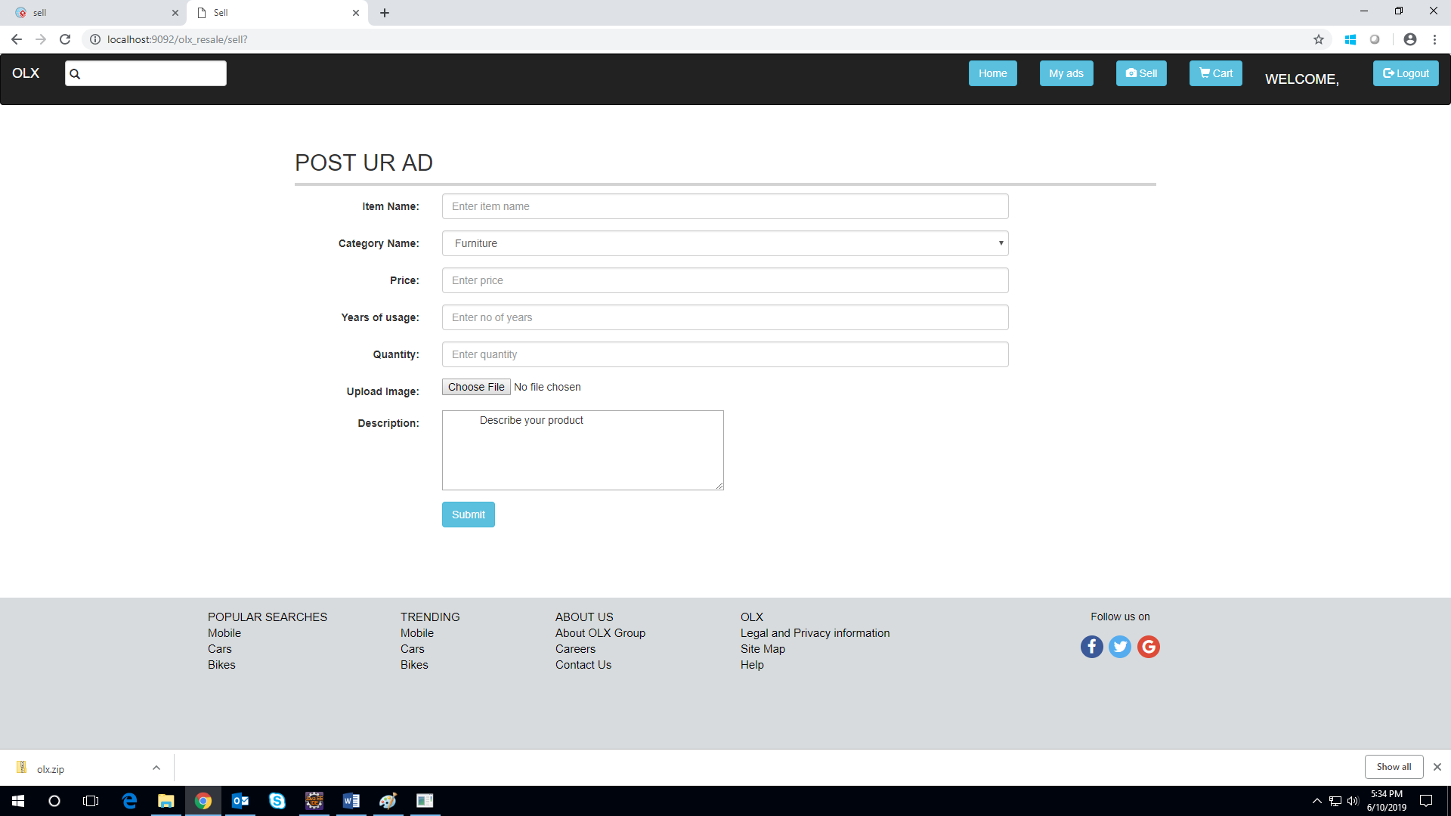

Here is a prototype on how the home page should display the product for which ad is posted

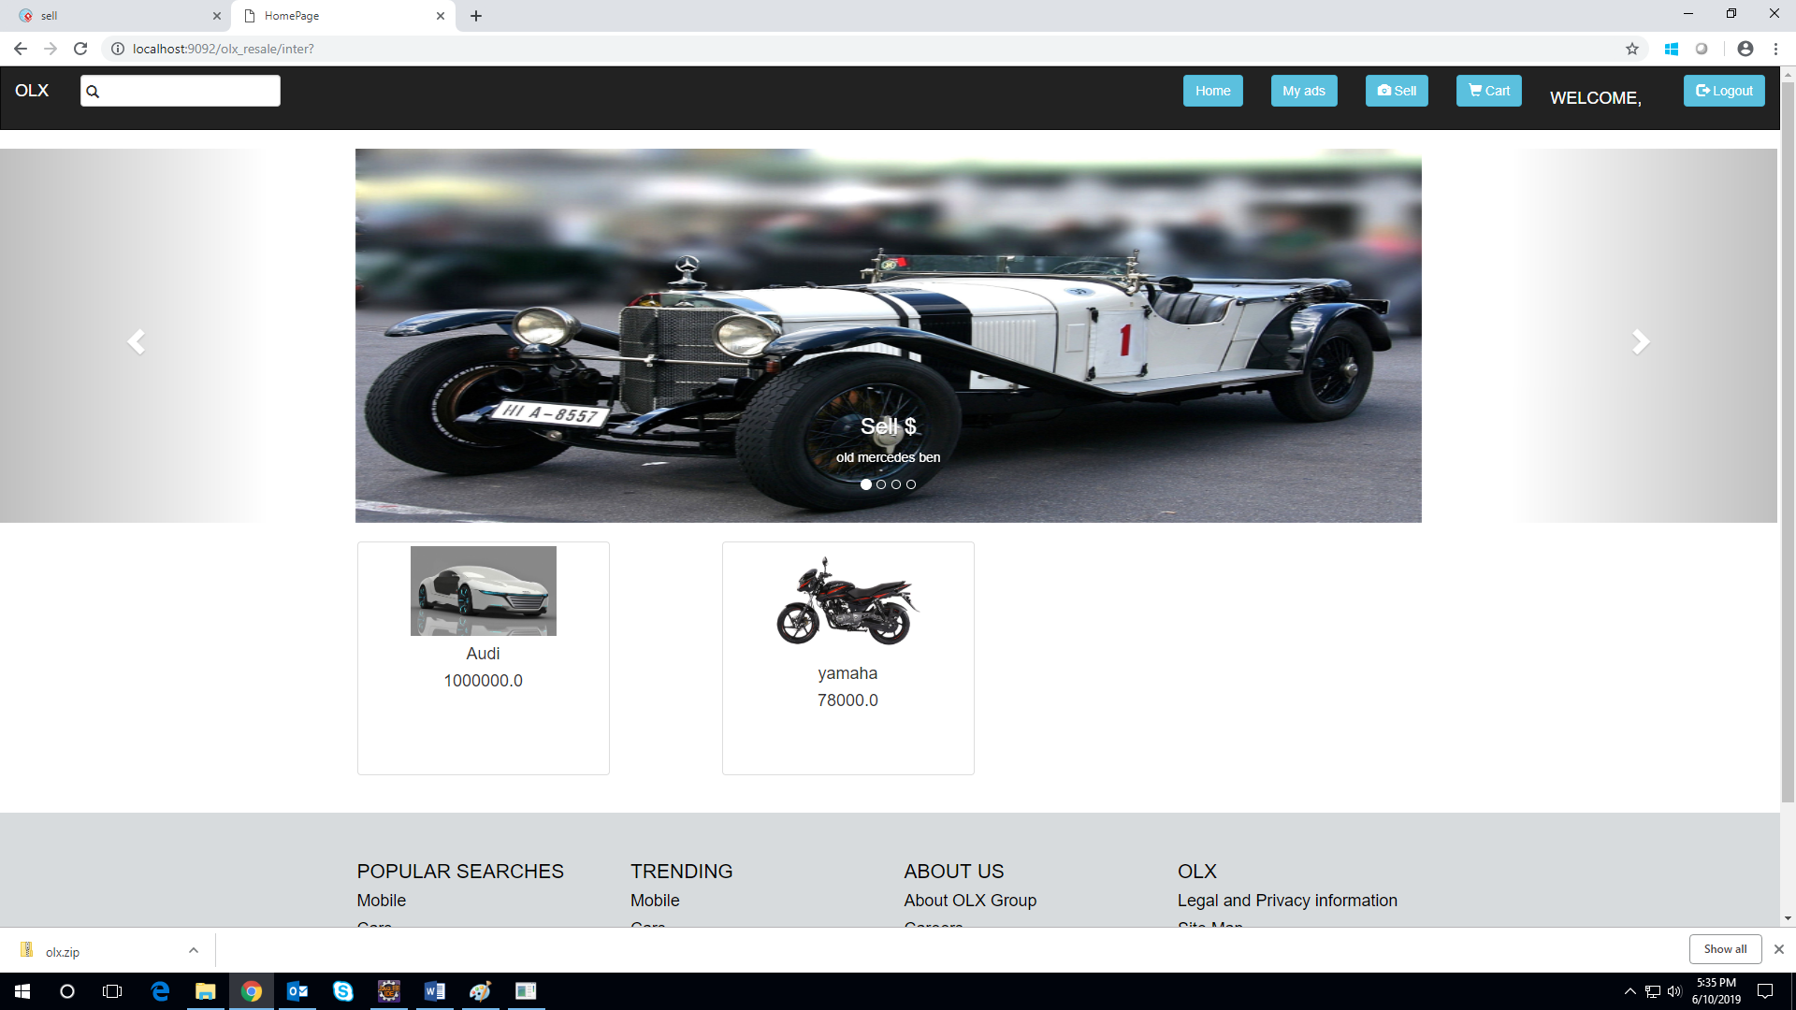

## Use case ‘Product description’

### Use case attributes

**Use Case Description:**

On clicking the image of the product in the homepage, the product description page for the particular product is displayed.

**Scope:**

* The product description provides details like description, price and seller details of the product.
* The product can be added to the cart by clicking “Add to cart” button.
* The product can be bought by clicking “Buy Now” button.

**Actors:**

Registered user who have successfully logged in.

**Trigger:**

Click the image to view the product description page.

**Pre-Condition:**

User must have successfully logged in.

**Post Condition:**

The user can add the product to the cart or buy the product.

**Flow of Events:**

Click the image of the product 🡪 Redirected to the product description page

**Primary Scenario:**

Click the image of the product, it is redirected to the product description page.

### Use Case Model

### Business Rules

Business rules should be defined using the following attributes: -

* Click “Add to cart” button, to add the product to the cart of the user.
* Click “Buy now” to buy the product.

### UI Requirement

Here is a prototype on how the product description page should look like

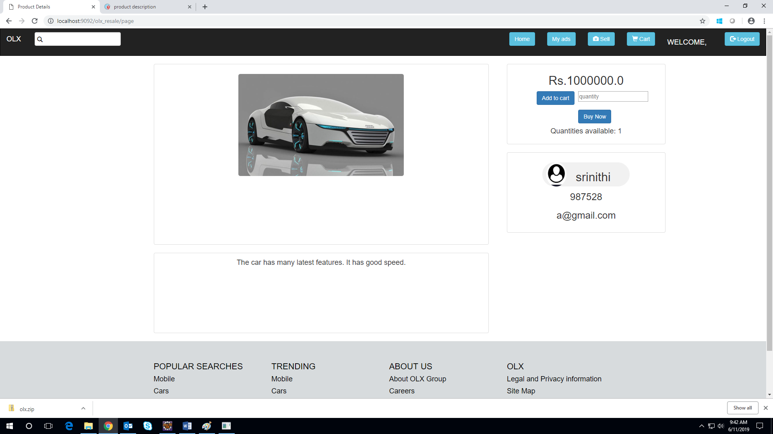

## Use case ‘User cart’

### Use case attributes

**Use Case Description:**

On clicking the “cart” button in the list of services page, it is redirected to the page displaying the list of products added by the user in the cart.

**Scope:**

* The product can be bought by clicking “Buy Now” button and providing the quantity in the quantity field.
* The product can be removed from the cart by clicking the “Remove” button.

**Actors:**

Registered user who have successfully logged in.

**Trigger:**

Click the “cart” button in the list of services page.

**Pre-Condition:**

User must have successfully logged in and viewed and added few products to the cart, otherwise the cart will be empty.

**Post Condition:**

* The list of products added to the cart can be viewed.
* The product can be removed from the cart by clicking the “Remove” button.
* The product can be bought by providing the quantity and clicking the “buy now” button.

**Flow of Events:**

Click the “cart” button 🡪 Redirected to the page displaying list of products 🡪 Click the “Remove” button 🡪 Remove the product from the cart 🡪 Provide the quantity 🡪 Click the “Buy Now” button 🡪 Payment page 🡪 Update the quantity in the database or remove the product from the database.

**Primary Scenario:**

Click the “cart” button in the list of services page.

### Use Case Model

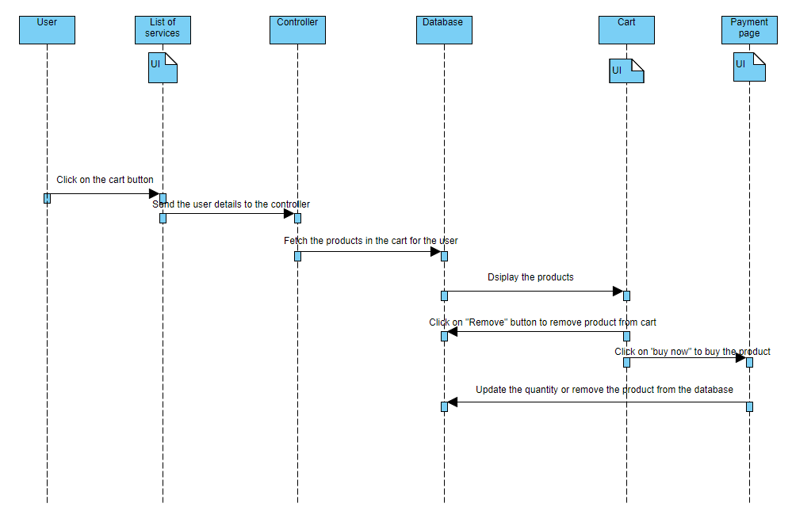

### Business Rules

Business rules should be defined using the following attributes: -

* Click “Remove” button, to remove the product to the cart of the user.
* Click “Buy now” to buy the product by providing quantity in the quantity field.

### UI Requirement

Here is a prototype on how the cart should look like

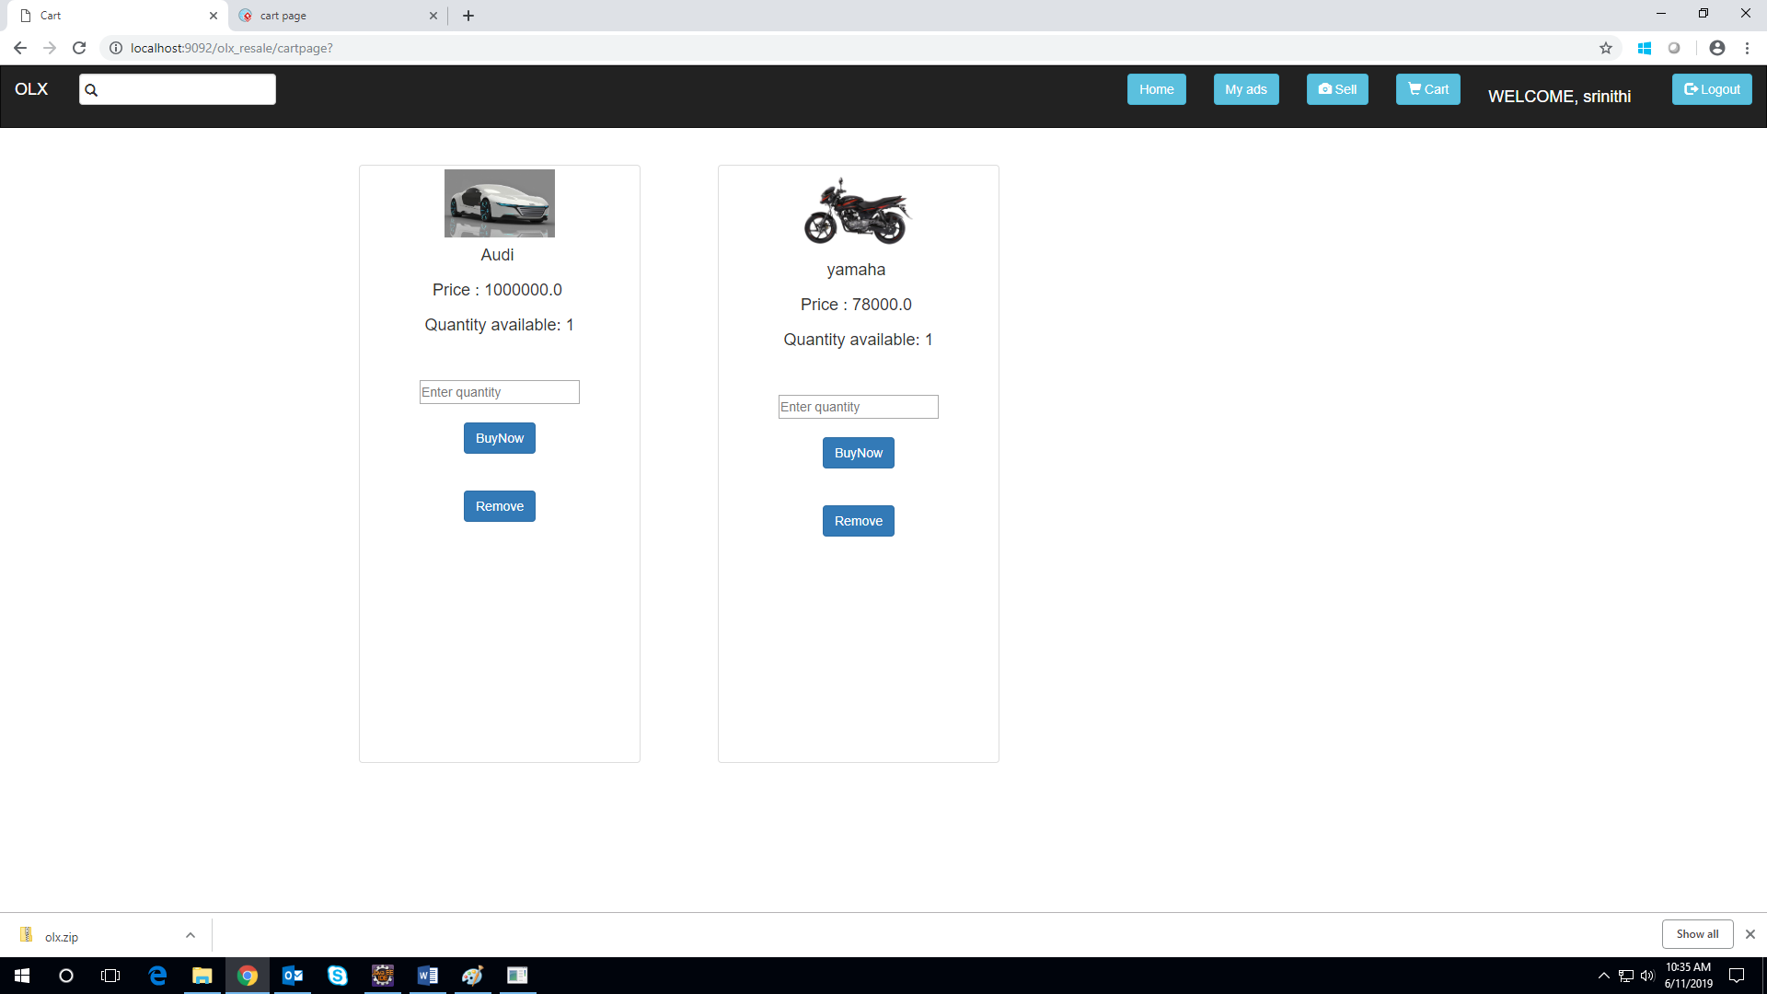

Here is a prototype on how empty cart page should look like

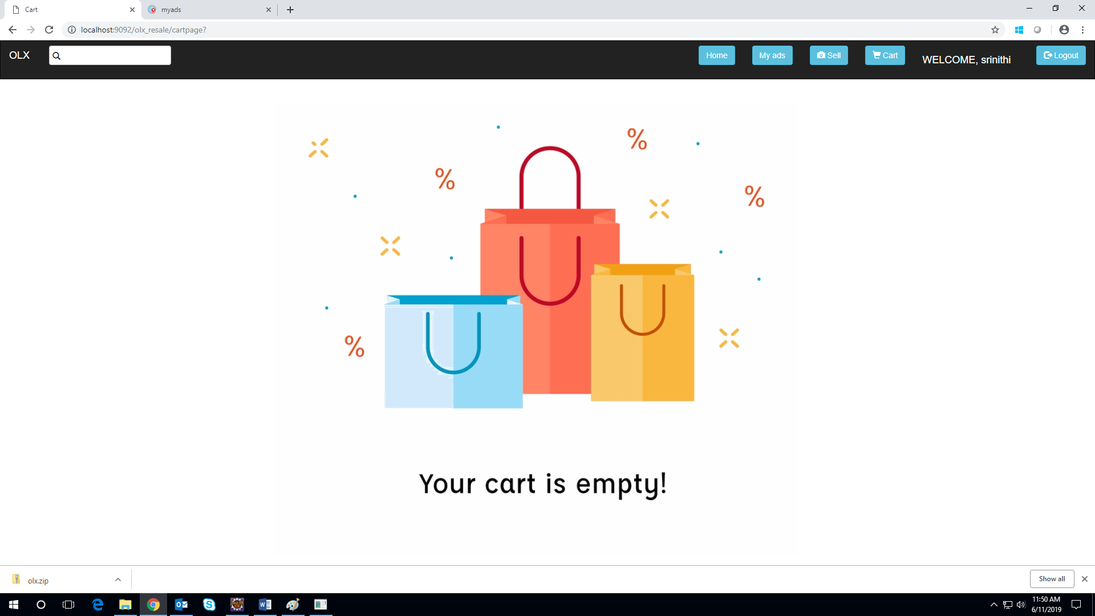

## Use case ‘User ads’

### Use case attributes

**Use Case Description:**

On clicking the “My ads” button in the list of services page, it is redirected to the page displaying the list of products posted by the user for sales.

**Scope:**

* The product can be edited by clicking “Edit” button.
* The product can be removed by clicking the “Remove” button.

**Actors:**

Registered user who have successfully logged in.

**Trigger:**

Click the “My ads” button in the list of services page.

**Pre-Condition:**

User must have successfully logged in and posted few ads, otherwise the ads page will be empty.

**Post Condition:**

* The list of products posted by the user can be viewed.
* The product can be removed from the selling by clicking the “Remove” button.
* The product details can be edited by clicking the edit button.

**Flow of Events:**

Click the “My ads” button 🡪 Redirected to the page displaying list of products posted by the user🡪 Click the “Remove” button 🡪 Remove the product from the my ads page 🡪 Click the “Edit” button 🡪 Redirected to the editad page.

**Primary Scenario:**

Click the “My ads” button in the list of services page.

### Use Case Model

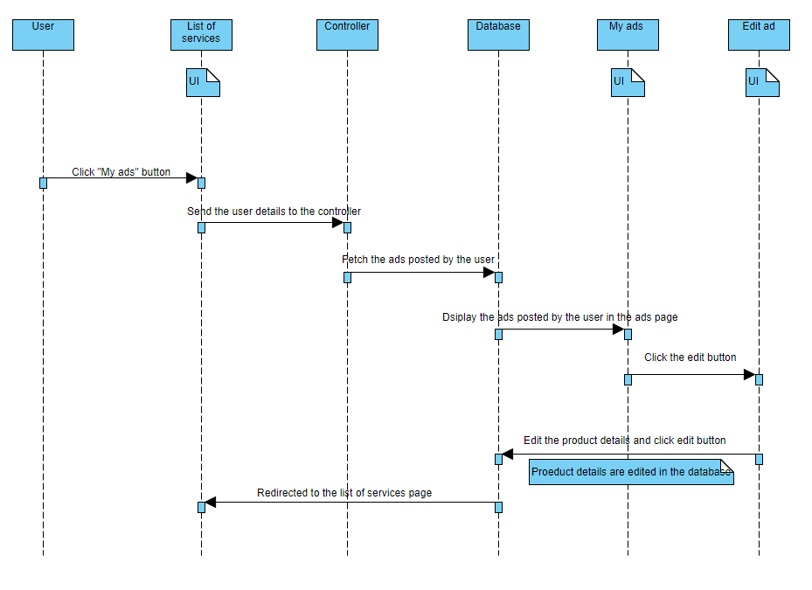

### Business Rules

Business rules should be defined using the following attributes: -

* Click “Remove” button, to remove the product from the list of ads posted.
* Click “Edit” button to modify the product details.

### UI Requirement

Here is a prototype on how my ads page should look like

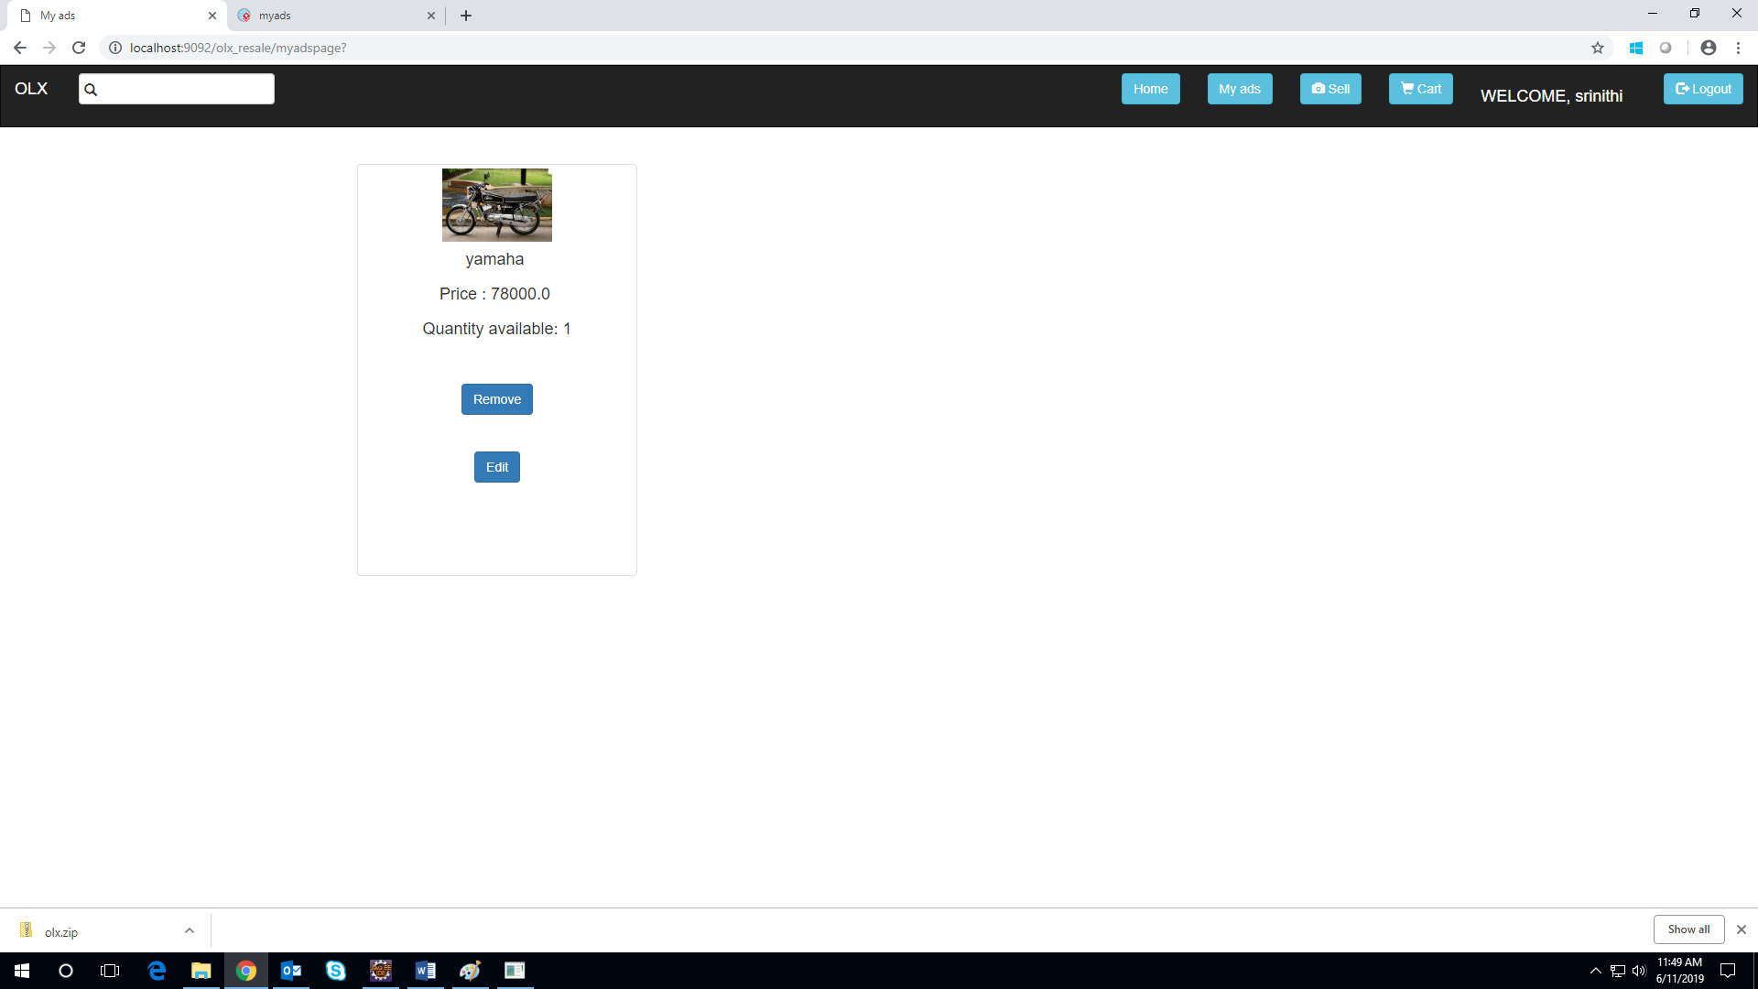

Here is a prototype on how empty my ads page should look like

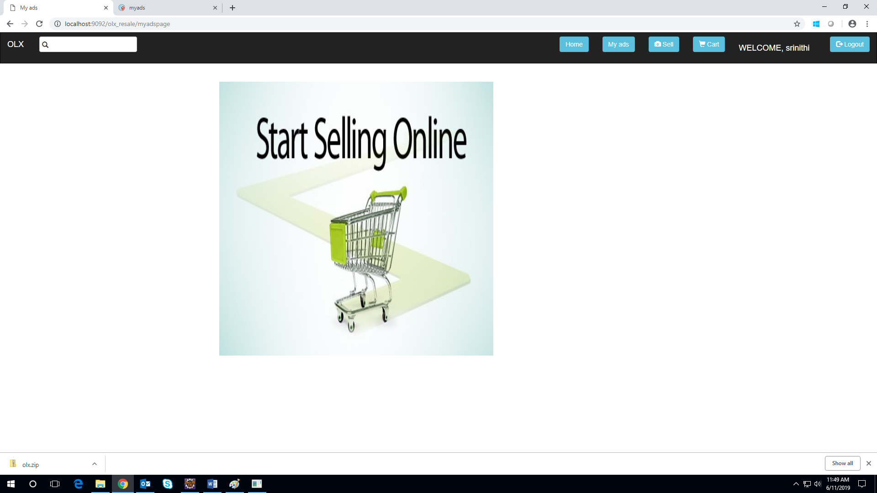

Here is a prototype on how edit ad page should look like

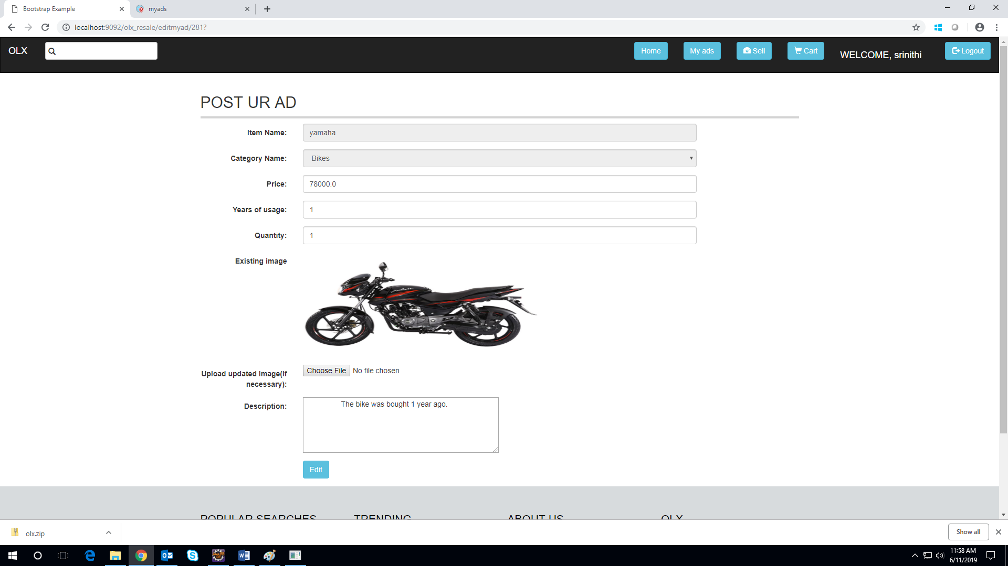

# Database Design

## Tables Structure

## List of tables:

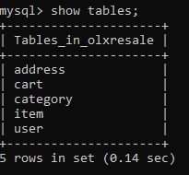

**User details:**

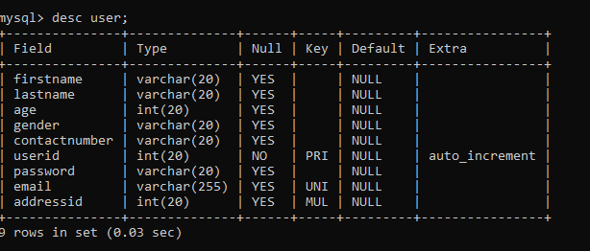

**Address details:**

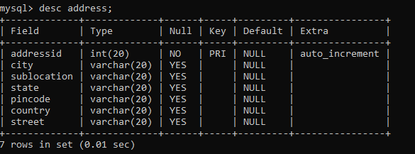

**Item details:**

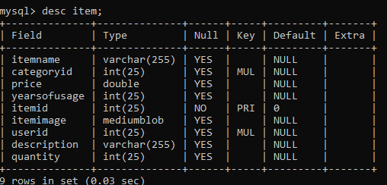

**Category details:**

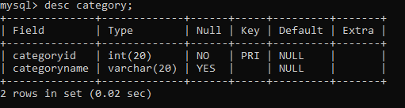

**Cart details:**

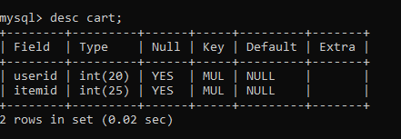

# Change Log

|  |  |
| --- | --- |
| Version Number | Changes Made |
| V1.0 | Initial baseline created on 16-04-2019 by Abiranjeetha A R, Srinithi I |
| V1.1 | Forgot password created on 27-05-2019 by Arulkumar K, Jeevanandham G, Shravan Karthic A |